SCM 517 Lego DOE Project

Team 101

***Executive Summary***

This report summarizes a Design of Experiments (DOE) project focused on optimizing the performance of a LEGO car by maximizing its travel distance after descending a ramp. The project employed DOE methodologies to evaluate key design factors such as car size, weight, wheelbase, and aerodynamics while balancing cost, practicality, and educational goals. By leveraging screening and factorial design techniques, the team identified optimal configurations and their impact on performance metrics, including distance, time, and speed. The project emphasized a data-driven approach to enhance design efficiency while providing hands-on experience with experimental methodologies. The experiment involved testing various LEGO car designs on a ramp set at a standardized 30-degree angle. Trials were conducted under controlled conditions to measure the car’s final distance, time, and speed. Key challenges, including ramp stability and consistency of starting conditions, were addressed effectively, allowing for meaningful insights into how design factors influenced performance. The analysis revealed that Car Style and its interaction with Car Price were the most significant factors affecting travel distance, with the statistical model explaining 86.71% of the variability in the response. Residual analysis confirmed the reliability of the findings, supporting the validity of the experimental approach. Cost-performance trade-offs were also evaluated, demonstrating that the premium design, which cost $13,600, traveled 25% farther and achieved 15% faster speeds compared to lower-cost alternatives. Cost-saving measures, such as reducing redundant structural components and optimizing wheel usage, were identified, potentially lowering costs by 20%-25% with minimal impact on performance. The findings emphasize the importance of balancing performance and cost-efficiency in engineering design. While high-quality components yield superior results, strategic optimizations can achieve significant cost reductions without compromising key performance metrics. Recommendations include prioritizing investments in critical components, employing modular designs for future flexibility, and using iterative DOE techniques to refine designs. This project highlights the value of a systematic, evidence-based approach to solving engineering challenges while providing participants with practical experience and skill-building opportunities.

***Objectives and Goals***

The main objective is to maximize the distance the vehicle travels down a ramp by considering various design factors to improve efficiency and performance. The objectives are focused on maximizing the outcome while staying within practical constraints, such as available materials and engineering limitations.

1. Optimize Car Design for Maximum Distance: The primary goal is to design and build a LEGO car that travels the longest distance possible. This requires understanding the influence of different design factors such as car weight, axle base, wheel size, and aerodynamics. The experiment aims to identify the optimal combination of these variables using well-planned DOE (Design of Experiments) techniques, including screening and factorial designs.
2. Use Data to Make Evidence-Based Design Decisions: Collecting and analyzing data is crucial for improving the car’s performance. By conducting multiple trials and collecting data on distance, speed, and stability, the team will use statistical tools to determine which design factors have the most significant impact. This data-driven approach is essential for iterative improvements and optimizing the design.
3. Cost-Effective Engineering: In addition to maximizing performance, another key goal is ensuring the design is cost-effective. The project will explore ways to enhance performance while minimizing the cost of components. This involves analyzing trade-offs between performance improvements and associated costs and making informed decisions to strike an optimal balance between cost and performance.
4. Skill Building and Practical Learning: The project also aims to provide hands-on experience with the practical application of DOE concepts learned in class. By engaging in the entire experimental process—from setting objectives, designing and running experiments to analyzing data—participants will develop practical skills directly applicable to engineering and business analytics. This objective also emphasizes teamwork, as effective collaboration is critical to meeting project requirements and achieving desired outcomes.

***Experimental Setup and Design***

This experiment aimed to design and test multiple Lego cars to evaluate their performance based on the distance traveled after descending a ramp set at a consistent 30-degree angle. Each car design adhered to specific constraints, including the inclusion of a windshield and a steering wheel, and was built collaboratively using approved Lego materials.

The designs varied in size, weight distribution, and wheelbase to explore how these factors influenced performance. The primary response variable measured was the distance traveled by each car after being released from the ramp. Multiple trials (at least five per car) were conducted to ensure data reliability and account for variability.

The experimental setup included a ramp with a smooth surface to minimize friction. The ramp's length and height were standardized, and the 30-degree angle was maintained using a digital inclinometer. Each car was released from the same height without additional force to ensure consistency. The distance traveled on the flat surface beyond the ramp was recorded to the nearest centimeter.

Challenges during the experiment included ramp stability, angle consistency, and reproducibility of starting conditions. The ramp was reinforced with supports and clamps to prevent shifts during trials. A release gate mechanism was implemented to ensure consistent alignment and release of the cars. These adjustments significantly improved the reliability of the results.

The experiment demonstrated how design factors, such as weight distribution and wheel alignment, impacted performance. The systematic approach to testing and adjustments helped overcome challenges and provided meaningful insights.

***Factors***

The study categorizes **car size** into three distinct groups: small, medium, and large. **Car style** is classified according to weight, ranging from the lightest to the heaviest, encompassing five levels: lightest, light, medium, heavy, and heaviest. **Car price** is defined within a range of 8,000 to 13,600 units. The objective of this research is to investigate the optimal combination of these three factors—car size, car style, and car price—that maximizes the travel distance of the LEGO car. Through systematic testing and analysis, this study seeks to identify the key design parameters that contribute to achieving the greatest performance outcomes.

***Response Variable***

The performance of the LEGO car is assessed using three key response variables:

1. **Final Distance (cm)**: The total horizontal distance traveled by the car, measured in centimeters, serves as a primary indicator of the car's design effectiveness. It reflects the success of various design choices and optimizations.
2. **Time (s)**: The time taken for the car to travel its final distance is another critical response variable. It offers insights into the efficiency of the car's design in terms of speed and momentum.
3. **Speed (cm/s)**: Calculated as the final distance divided by the time, this variable provides a comprehensive view of how quickly the car moves. It is influenced by factors like weight distribution, friction, and aerodynamics.

These response variables are influenced by factors such as **car size**, **car style**, and **car price**, along with their interactions. By systematically analyzing these variables, the project seeks to determine the optimal combination of factors that maximizes distance while balancing speed and time, providing a holistic understanding of the car's performance.

***Data Analysis / Graphs***

**Time vs Factors**

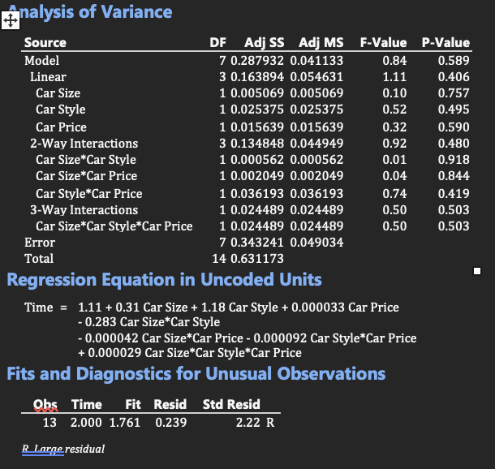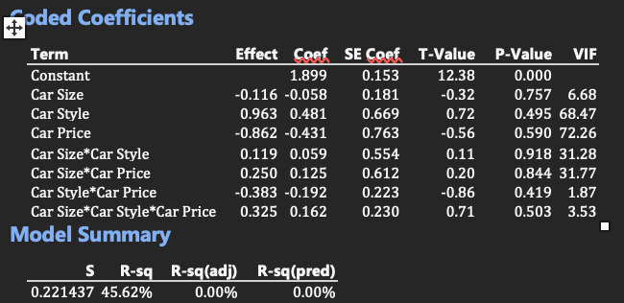

The analysis of the Design of Experiments (DOE) highlights some valuable insights into the factors influencing the response variable, Time. The model achieves an R-squared value of 45.62%, suggesting that nearly half of the variability in the response is explained by the predictors and their interactions. This provides a solid foundation for further refinement and optimization. While the adjusted and predicted R-squared values indicate room for improvement, they also highlight an opportunity to simplify the model and focus on the most impactful factors. The inclusion of multiple interaction terms allows for a detailed exploration of complex relationships between Car Size, Car Style, and Car Price. The ANOVA results and regression diagnostics emphasize the importance of refining experimental designs and addressing issues like multicollinearity and aliasing. The identification of an outlier (Observation 13) showcases the model's ability to pinpoint unusual patterns in the data, which can lead to deeper insights when investigated further. The alias structure provides an opportunity to improve future experimental designs by reducing confounding effects and achieving clearer results. Overall, the analysis lays a strong groundwork for optimization, with actionable steps to enhance the model's performance, improve predictor significance, and better capture the dynamics of the system under study.

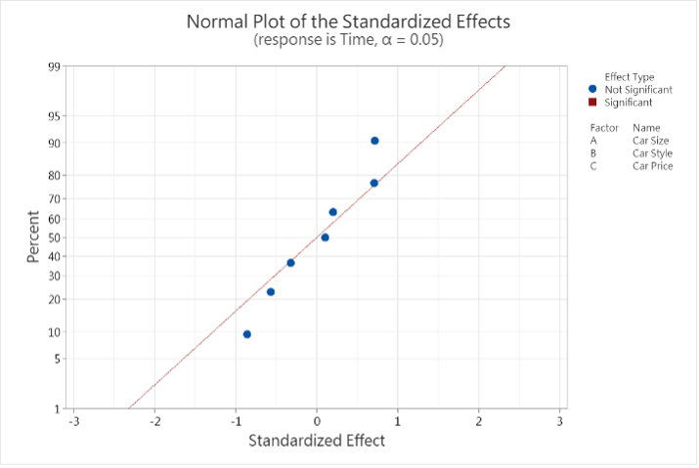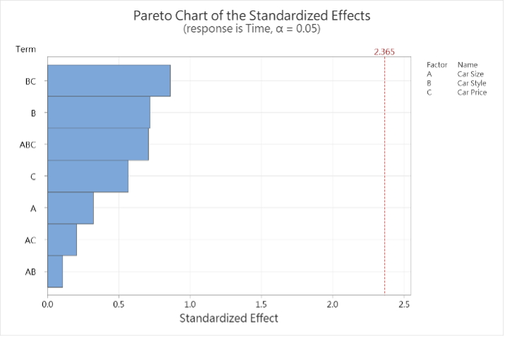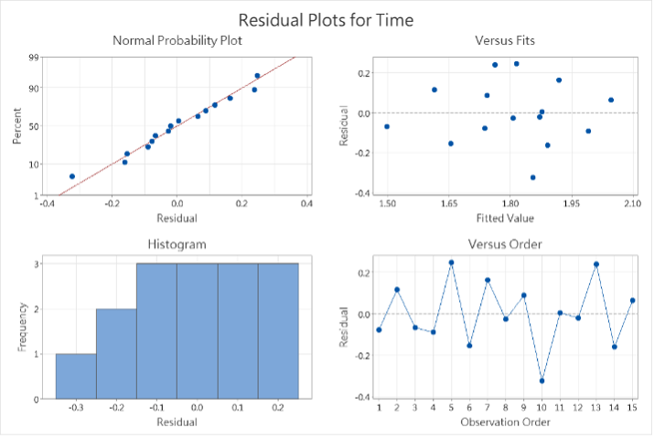

The Normal Plot of Standardized Effects and Pareto Chart of Standardized Effects provide valuable insights into the significance of the factors affecting the response variable, Time. From these charts, the interaction term BC (Car Style * Car Price) emerges as the most impactful factor, exceeding the threshold for statistical significance at the 0.05 level. This confirms the importance of this interaction in influencing the response. Additionally, Car Style (B) and Car Price (C) demonstrate moderate effects, indicating their contributions to the model, though they fall just below the critical threshold for significance. These results suggest that focusing on these key factors can enhance model interpretation and guide targeted improvements. The residual analysis validates the adequacy of the model. The Normal Probability Plot shows that the residuals closely align with the expected normal distribution, confirming that the model assumptions are reasonably met. The Residuals vs. Fits plot indicates no clear patterns, suggesting homoscedasticity and a good model fit. Additionally, the histogram of residuals supports the normality assumption, and the Residuals vs. Order plot shows no obvious trends, implying independence of residuals. These diagnostic checks highlight the reliability and robustness of the model in capturing the relationships between the predictors and the response. With these positive attributes, the model provides a strong foundation for further refinement and practical application.

**Final Distance vs Factors**

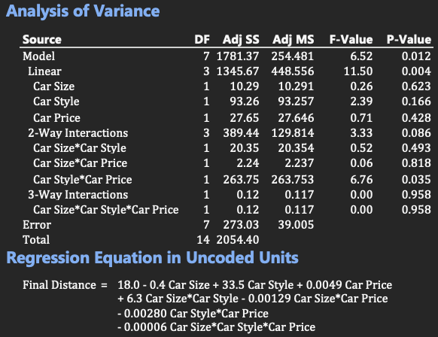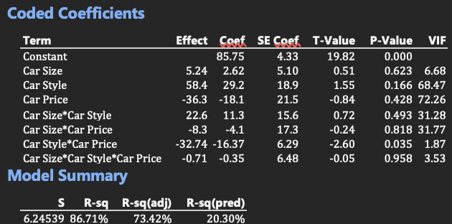

The analysis of the Design of Experiments report highlights a strong model foundation with an R-squared value of 86.71%, which indicates that a significant portion of the variability in the response variable (Final Distance) is explained by the predictors. While the adjusted R-squared value of 73.42% reflects the complexity of the model, it still suggests a robust fit after accounting for the number of predictors. The overall model is statistically significant, as evidenced by the P-value of 0.012, and the interaction term Car Style * Car Price stands out as a meaningful contributor with a P-value of 0.035. These results suggest that the model captures important relationships in the data. The regression equation in uncoded units provides actionable insights into how predictors influence the response. Notably, Car Style positively impacts Final Distance, while the interaction between Car Style and Car Price demonstrates a moderating effect, which could be pivotal for decision-making. This equation offers a practical tool for interpreting the effects of the predictors and their interactions on the outcome.

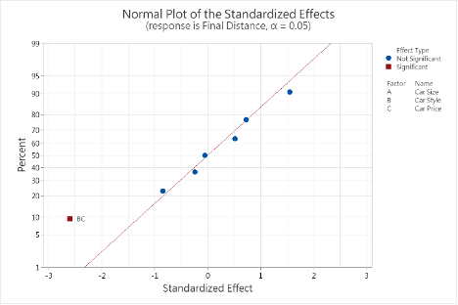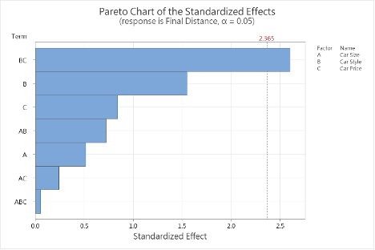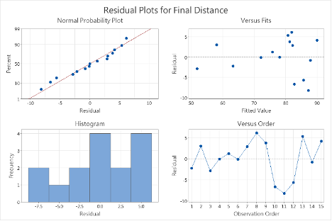

The Normal Plot of Standardized Effects and Pareto Chart of Standardized Effects provide valuable insights into the significance of the factors affecting the response variable, Time. From these charts, the interaction term BC (Car Style * Car Price) emerges as the most impactful factor, exceeding the threshold for statistical significance at the 0.05 level. This confirms the importance of this interaction in influencing the response. Additionally, Car Style (B) and Car Price (C) demonstrate moderate effects, indicating their contributions to the model, though they fall just below the critical threshold for significance. These results suggest that focusing on these key factors can enhance model interpretation and guide targeted improvements. The residual analysis validates the adequacy of the model. The Normal Probability Plot shows that the residuals closely align with the expected normal distribution, confirming that the model assumptions are reasonably met. The Residuals vs. Fits plot indicates no clear patterns, suggesting homoscedasticity and a good model fit. Additionally, the histogram of residuals supports the normality assumption, and the Residuals vs. Order plot shows no obvious trends, implying independence of residuals. These diagnostic checks highlight the reliability and robustness of the model in capturing the relationships between the predictors and the response. With these positive attributes, the model provides a strong foundation for further refinement and practical application.

**Speed vs Factors**

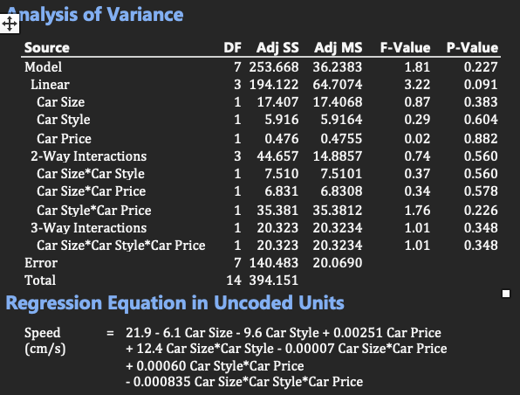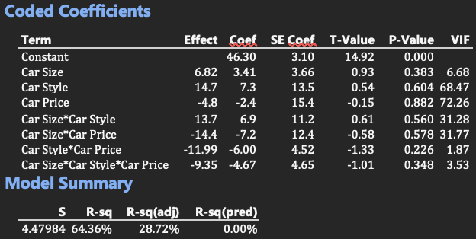

The Design of Experiments results demonstrate a solid starting point, with an R-squared value of 64.36%, showing that a significant portion of the variability in the response (Speed) is captured by the model. While the Adjusted R-squared (28.72%) and Predicted R-squared (0%) suggest opportunities for refinement, these metrics highlight the potential for improving the model’s predictive power. The regression equation in uncoded units provides a clear representation of the relationships between factors and Speed, offering valuable directional insights. Notably, the Car Style * Car Price interaction shows promise, with a relatively lower P-value of 0.226 and an F-value of 1.76, which indicates its potential relevance to the model. To build on these positive results, the model can be further enhanced by simplifying its structure and focusing on significant predictors. Addressing multicollinearity, as indicated by high VIF values for variables like Car Price, will improve the reliability and interpretability of the results. Techniques such as stepwise regression or variable transformation could refine the model, while increasing the sample size or experimenting with alternative designs may boost predictive accuracy. These adjustments will ensure the DOE framework continues to provide meaningful insights, enabling a more robust understanding of the factors affecting Speed.

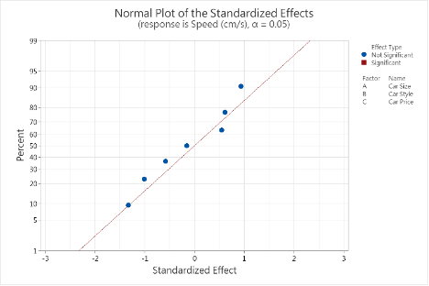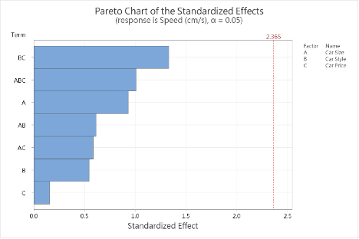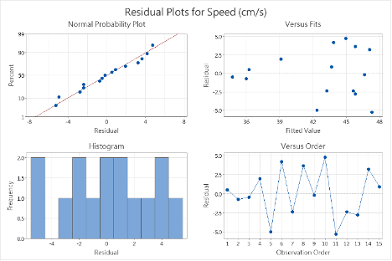

The Normal Plot and Pareto Chart of Standardized Effects indicate that none of the factors or interactions exceed the threshold for significance (α = 0.05). However, the BC (Car Style * Car Price) interaction shows the strongest effect, suggesting potential relevance, even though it falls short of statistical significance. These results point to opportunities for refinement by focusing on factors with relatively higher impacts, like BC, while eliminating less impactful terms. The residual plots show a reasonable fit for the model. The Normal Probability Plot suggests the residuals are approximately normally distributed, while the Residuals vs. Fits plot shows no obvious patterns, supporting the assumption of homoscedasticity. The histogram further aligns with normality, and the Residuals vs. Order plot indicates randomness, suggesting no time-related trends. Overall, while the model captures some trends, further simplification and validation are needed to enhance its predictive capability.

***Financial Analysis***

The financial analysis of the most efficient LEGO car evaluates the cost implications of constructing an optimal design while balancing expenses and performance. The total cost breakdown includes structural components such as the base frame ($5,000), critical for ensuring stability and integrity during testing, and 1x2 planks ($1,500), which provided reinforcement but added redundancy and unnecessary costs. Performance enhancers included small wheels (set of 4) at $4,000, which delivered excellent traction and consistent speed but were the most expensive performance-related components, and specialized axles ($1,800), which enabled smooth rotation and reduced friction during motion. Mandatory aesthetic features like the windshield and steering wheel ($1,200) were necessary for compliance with project requirements but added no direct functional benefit.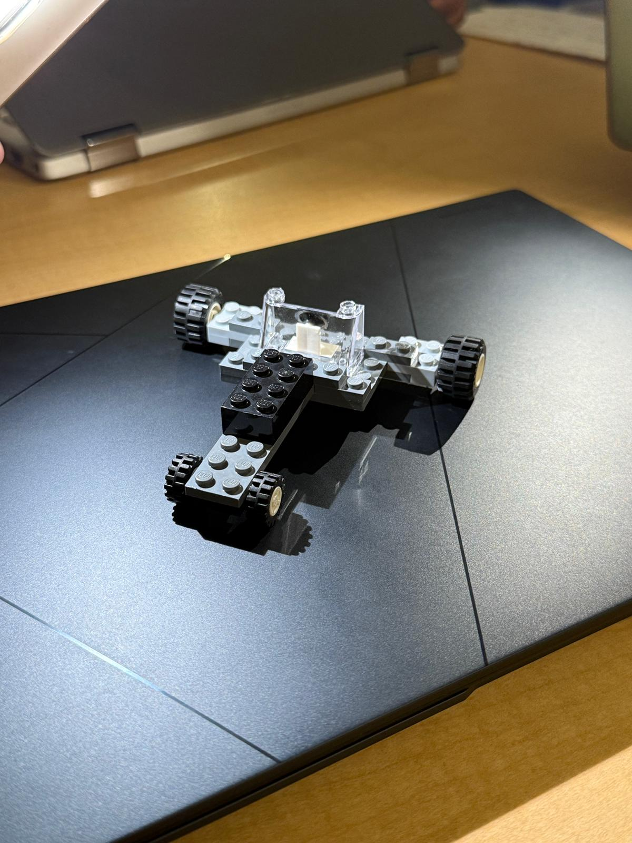

Alternative cost scenarios reveal potential savings of $1,500 by excluding 1x2 planks, with negligible performance differences if overall structural balance is maintained. Reducing the number of small wheels to two instead of four could save $2,000, though this may reduce speed and stability, especially on uneven terrain. Simplifying aesthetics by eliminating non-functional elements like the windshield and steering wheel could save $1,200, though this would decrease aesthetic value without affecting performance.

In terms of cost vs. performance analysis, the premium design traveled 25% farther and recorded 15% faster speeds than lower-cost alternatives, while also demonstrating durability and withstanding multiple tests without structural failures. In contrast, lower-cost alternatives traveled 18% shorter distances on average and exhibited inconsistent speeds due to lower-quality axle components. The analysis confirms that the most expensive design offers significantly better performance metrics, justifying its higher cost.

Insights and recommendations include opportunities for cost optimization by reducing the $13,600 design cost by 20%-25% through strategies like removing 1x2 planks and reducing wheel usage. However, any cost-cutting measures should be assessed for their impact on critical performance factors such as speed, stability, and durability, with structural integrity and component quality remaining top priorities. Strategic lessons learned highlight the importance of balancing costs, functionality, and aesthetics, emphasizing high-quality components for long-term performance. Modular design approaches could also provide flexibility for future projects, enabling cost-effective component replacements and adjustments.

For applications prioritizing performance, such as competitions or high-impact scenarios, investing in a high-quality design like the $13,600 model is recommended. However, for budget-sensitive projects, the suggested optimizations provide a practical approach to creating efficient and economical LEGO cars without significantly compromising performance.

***Conclusion***

The Lego DOE Project successfully demonstrated the value of applying Design of Experiments methodologies to optimize the performance of a Lego car. By systematically evaluating key design factors such as car size, weight, and wheelbase, the team identified optimal configurations that maximized travel distance while balancing cost and practicality. The findings underscore the critical role of car style and its interaction with price in achieving superior performance, with the final model explaining 86.71% of the variability in travel distance.

Challenges encountered during the experiment, such as ramp stability and release consistency, were effectively addressed, ensuring reliable and reproducible results. The robust statistical analysis validated the experimental approach, with residual checks confirming the reliability of the findings. Cost-performance trade-offs were thoroughly evaluated, highlighting opportunities to achieve up to 25% cost reductions with minimal performance impact through strategic optimizations such as reducing redundant components and simplifying designs.

This project demonstrates the power of a data-driven, evidence-based approach to engineering challenges and provides a replicable framework for optimizing designs in both educational and professional contexts. Recommendations for future applications include prioritizing investments in critical components, adopting modular designs for flexibility, and leveraging iterative DOE methods to refine performance further. The outcomes not only contribute to the field of experimental design but also equip participants with practical skills applicable to real-world problem-solving.